
Preparing for Puberty – Year 5

HH Kids offer a separate boys preparing for puberty lesson, and a girls preparing for puberty lesson aimed at Year 5 pupils. HH Kids are dedicated to working within a school’s policy and procedures and carry out an initial pre-meeting with a member of staff to ensure the lessons meet school needs. The lessons are interactive with a wide variety of activities to meet the different learning styles of pupils.

Preparing for puberty
Boys’ lesson

- To explain when and how puberty starts
- To give examples of some of the physical body changes as we approach puberty
- To describe different feelings as we go through puberty and how to deal with them positively
- To recognise the need for good personal hygiene

Preparing for puberty
Girls’ lesson

- To explain when and how puberty starts
- To give examples of some of the physical
body changes as we approach puberty
- To explain the menstrual cycle and the
products available
- To describe different feelings as we go
through puberty and how to deal with them
Contact Us
Joanne Hill / Louise Meekin - 07542 767176
E-mail: contact@hhkids.co.uk Website: www.hhkids.co.uk

An optional parent awareness session is also available to schools
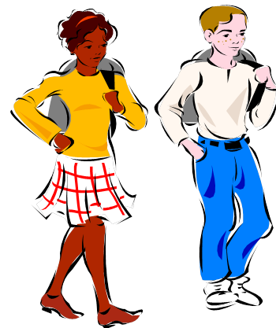
positively

